First Aid Training Review Template
A trauma-informed approach realises the widespread impact of trauma and understands potential paths for healing. It recognises that everyone has a role to play.
Trauma-Informed Wales Framework | A Societal Approach to Understanding, Preventing and Supporting the Impacts of Trauma and Adversity
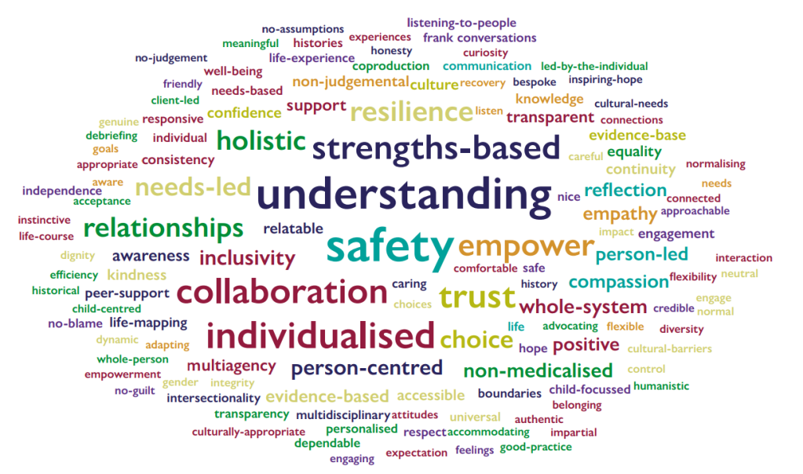
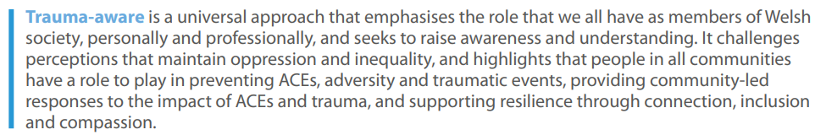
Trainer(s)
Organisation
Course name

Course dates
Joining instructions
See example.
Location
Where can participants go to unwind? Is there a green space nearby?

Structure of course, breaks & self-care opportunities
Does the course build up to potentially distressing content? Are there sufficient breaks for participants to practice self-care?

Ground rules & icebreakers
How does the trainer ensure that participants feel comfortable, respected and supported during training?

Confidential opportunity to discuss needs
Is there an opportunity for learners to confidentially raise concerns?

Fight, Flight, Freeze > First Aid
Is there discussion of the Fight, Flight, Freeze reaction and how to stay calm under pressure?
Are Freeze reactions discussed too?

Vicarious Trauma
Is the potential impact of witnessing or providing support in an incident discussed? Here are some factors to consider

First Aiders Post Traumatic Wellbeing
Is there a designated slide or exercise to promote Post Traumatic Wellbeing?

Signposting to relevant support
Are there adequate signposts to support First Aider Wellbeing e.g. Support after cardiac arrest?

Content warnings
Are there any content warnings when enrolling on the course? Are upcoming topics introduced? Is content warning provided before showing potentially distressing media, e.g. videos?

Triggering content
How are real-life videos used? How might people with lived experience of topics be effected?

Managing Distress
Is it possible for learners to leave the classroom quietly?
Is the First Aider trained in Mental Health First Aid and able to respond to distress?

First Aid ethics
Are learners provided with sufficient training to recall what to do during an emergency? Are agonal breaths sufficiently explained and understood?

Awareness of potential trauma history
Are learners who have provided emergency First Aid put on the spot?
Are role-play activities used appropriately?

Awareness of consent
Is the importance of consent discussed in the context of First Aid?

Awareness of intergenerational trauma
Are symptom differences in black and brown skin discussed? See Mind the Gap — Black & brown skin

Awareness of Adverse Childhood Experiences (ACEs)
Is any reference to ACEs made?

Physical / Mental Health First Aid cross-overs
Are learners aware of the chain of survival and the importance of the primary assessment, 999 call and AED? Are opportunities to explore First Aid / Mental Health First Aid / Psychological First Aid explored (e.g. How to provide First Aid care for an overdose on a suicide prevention course)

Humour, terminology & sensitivity
Are any jokes made that might be upsetting? Are role-play activities done appropriately? Are outdated phrases used (e.g. commit suicide, manic depression)?

Potential for remembrance and post-traumatic growth?
Could the course support post-traumatic growth? e.g. Light up the Night - Cruse Bereavement Support

Questions Raised:
Were any difficult questions raised about specific scenarios that need further research?
- E.g. What should a male First Aider do to help a non-breathing unconscious female wearing religious headwear – bare chest for AED?
- Is checking a responsive casualty’s gums for pallor practical in a First Aid context? (In reference to brown and black skin pallor)

